Ping 192.168.100.1

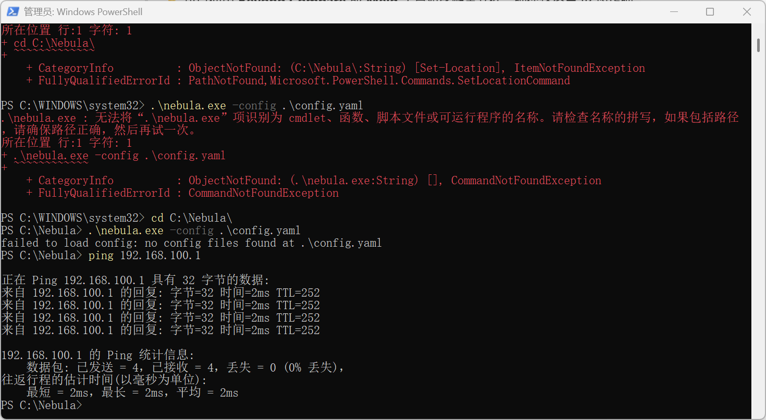

Log in ssh nuist@192.168.100.1

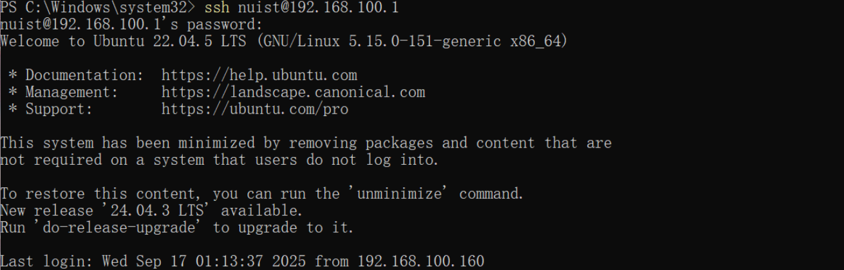

Ping google

